Feasibility Study of a Reconfigurable Fiber-Wireless Testbed using Universal Software Radio Peripheral

M.A. Ridwan¹, N.A.M. Radzi¹*, F. Abdullah¹, N.M. Din¹, and A. Zakaria²
¹Dept. of Electronics and Communication Engineering, College of Engineering, Universiti Tenaga Nasional, Jalan Ikram-Uniten, 43000 Kajang, Malaysia.
²Strategy, Partnership and Transformation Department, ICT Division, Tenaga Nasional Berhad, 50470 Kuala Lumpur, Malaysia
Received 15 June 2011; received in revised form 05 August 2010; accepted 10 September 2010

Abstract
Fiber-wireless network is under an on-going stage of improvements with a number of testbed available in the literature nowadays. However, most of them are purely hardware based testbed making them not easy to reconfigure in order to perform architecture or protocol studies. This paper proposes for the first time to the best of our knowledge, an easily reconfigurable FiWi testbed using software defined radio, particularly Universal Software Radio Peripheral (USRP) with LabVIEW as its platform for simulation. In order to evaluate the testbed, a wireless range and power output test have been first done to identify the best output power to be used for desired USRPs’ range. It is identified that for 100 m wireless range, the most suitable output power to be used is 30 dB. Afterwards, the paper evaluates the performance of the upstream FiWi testbed transmission in terms of throughput, transmission time and jitter. In order to test the reconfigurability feature of the testbed, we have also changed the architecture and the type of transmission of the testbed and studied the performance. The results indicate that USRP is suitable to be used as a reconfigurable FiWi testbed.

Keywords: Fiber wireless, testbed, reconfigurable, USRP

- Introduction

Nowadays, Internet has evolved from luxury to necessity. Massive sudden increment of Internet subscribers combined with bandwidth hunger Internet applications have been observed worldwide. Besides, the needs of having uninterrupted Internet connections while on-the-go caused mobility to be highly on demand. The integration of fiber optics with wireless link creates a fiber wireless (FiWi) network that provides a prestigious architecture for next generation network. This network is able to support higher data rates and overcome mobility issues in current access network [1].
FiWi is typically deployed using Passive Optical Network (PON) architecture. PON begins at the Optical Line Terminal (OLT) that is connected to the Optical Network Units (ONUs) via fiber link. The back end connects the ONUs wirelessly to the wireless gateways [2]. Technologies such as time division multiplexing PON (TDM PON) and wavelength division multiplexing PON (WDM PON) are typically used as multiplexing techniques in FiWi. TDM PON is recognised as a cost effective solution while WDM PON has a simpler arbitration mechanism. Wireless front-end uses technologies such as Wireless Fidelity (WiFi), Worldwide Interoperability for Microwave Access (WiMAX) [3], Long Term Evolution (LTE) or Wireless Mesh Networks (WMN) [4] are used in FiWi network.
Two approaches are used to transmit large amount of delay-sensitive data in FiWi; either through radio over fiber (RoF) or radio and fiber (R&F). RoF is a technique where radio frequency (RF) signals are converted into optical signals using converter. The signals are then propagated over a fiber link from the OLT to remote antenna units (RAUs). It will further be transmitted to clients wirelessly [5]. All the controls for RoF are centralized in the OLT. Hence, OLT is considered as network center of intelligence while RAUs only responsible for signal conversion. One of the advantages of RoF is that only minimal modifications are required at the RAUs since RF signals are transmitted to remote antenna as it is.
Radio and Fiber (R&F) on the other hand uses different media access control (MAC) protocols for both wireless and fiber link [6]. One of the R&F advantages is its ability to solve the insertion loss of the optical distribution system in wireless networks since R&F uses different protocols for different link.
To date, FiWi network is still in the stage of emerging and improving. Numerous FiWi related testbed has been developed for various purpose by the researchers.
On the wireless side, Kal et al. [7] has developed an open WiFi platform designed with special consideration of real-time signal by using software defined radio (SDR) at the front end. With the benefits of SDR, their proposed platform supports fast prototyping and verification of new physical layer algorithms as well as the 5G with WiFi network architecture and upper layer evolutions.
Hizan et al. [8] presents a testbed design using SDR platforms for the next generation wireless access network that supports concurrent multiservice transmissions in which a heterogenous network is emulated. Their testbed results show that the measured error vector magnitudes are suitable for WiFi and LTE Access Points to operate effectively as receivers.
Kamsula et al. [9] reviews the major challenges and important applications of hybrid visible light communication (VLC)/RF networks using a SDR-based testbed. Given the low cost, minimal hardware requirements and experimentally flexible feature of SDR, the proposed testbed represents an ideal system to begin various VLC/RF related experiments in the future.
Chen et al. [10] proposed a W-band fiber-wireless-fiber (Fi-Wi-Fi) transmission using directly modulated laser (DML) for the conversion of electrical to optical signals. The DML is tested using a testbed that consists of many devices such as external cavity laser, I/Q modulator, Erbium-doped fiber amplifier and optical attenuator. Chen et al. has proven in his paper that DML is a simple and cost-effective converter which can successfully be used in the Fi-Wi-Fi testbed proposed.
Shaddad et al. [11] also proposed a FiWi network system based on WDM/TDM PON for optical backhaul and WiFi-WiMAX wireless front end. The proposed FiWi system is simulated and analysed via a testbed that consists of laser diode, photodiode, low past filter with decoder, arrayed-waveguide-grating router and passive optical splitter. The testbed has achieved 2.5 Gbps for both up and downlink for fiber back-haul and 54 Mbps and 30 Mbps for wireless front-end in the distance of 50 m and 5 km respectively.
Zhang et al. [12] proposed a full duplex FiWi testbed that is equipped with optical I/Q modulator, two parallel Mach Zehnder modulator, phase shifter, optical local oscillator and tuneable laser. This paper has successfully demonstrated the feasibility of the proposed full-duplex link to be used for the future integration of wired and wireless networks.
Although the testbed mentioned [10-12] achieved the objectives intended successfully, they are all purely hardware-based testbed. Hardware-based testbed requires tedious hardware setups and they are not easily configurable, making them less suitable for architecture and protocol testing. As FiWi is still in the process of emerging, the best architecture and protocol are still being studied to improve the overall performance of the network. Therefore, it is essential to develop an easily reconfigurable testbed to observe the performance of various architectures and protocols for the FiWi network.
One of the best solutions in developing the testbed is by using a programmable radio. Radio is a device that has the ability to exchange digital data from a transmitter to a receiver. There are two types programmable radio; software controlled radio (SCR) and SDR. SDR is a radio system where all the signals processing, modulations and demodulations are implemented inside a computer. It is software defined where any technology can be implemented easily in the radio simply by programming. SDR takes advantage of modern digital signal processing techniques to obtain reconfigurability, modulation and coding encryption with RF front-end characteristic. The main difference between SDR and SCR is that the SDR is able to be reprogrammed for different functionality as compared to SCR.
In this paper, to the best of our knowledge, Universal Software Radio Peripheral (USRP) is used for the first time to develop an easily reconfigurable FiWi testbed for architecture and protocol testing. USRP is a programmable SDR that is manufactured by National Instruments (NI). One of the many advantages of USRP is its ability to be reprogrammed and to operate in the license free ISM bands which is 2.4 to 2.5 GHz. The USRP based FiWi testbed will be used for testing in a real and controlled environment for analysis. The remainder of this paper is organized as follows. In Section 2, we introduced the design of the FiWi testbed. The performance evaluation is discussed in Section 3. The results and discussion are presented in Section 4. We summarized our conclusion in Section 5.

- Proposed FiWi Testbed Design

In this section, we present our proposed FiWi testbed that combines the advantages of USRP and LabVIEW. USRP is a computer hosted RF transceiver that is able to transmit and receive RF signals in several bands. It runs on Gigabit Ethernet (CAT 6) cable to connect to a host computer where the signal processing and modulated signal streams to the USRP.
Variety of USRPs are available in the market such as standard USRPs, USRP RIO and FlexRIO. Standard USRPs are further subdivided into USRP-292x and USRP-293x. USRP-293x series are equipped with Global Positioning System (GPS) which is not a requirement for our FiWi testbed at the moment. With that, our chosen USRP for our proposed testbed is the USRP-292x series, particularly USRP-2922 since our focus is to transmit at 2.5GHz frequency band. The comparison between standard USRPs is as shown in Table 1. From the table, it can be concluded that USRP-2920 offers a narrower frequency range and USRP-2921 does not offer simultaneous Transmit/Receive, hence justifying the significance of using USRP-2922 in our FiWi testbed. The basic specifications of USRP-2922 are as shown in Table 2.
Four sets of USRP-2922 are used for the proposed FiWi network testbed. The first USRP, SDR 1 represents the OLT, SDR 2 and SDR 3 represent ONU 1 and ONU 2 respectively whereas SDR 4 represents the End-User creating a hardware setup as in Figure 1. Each SDRs are connected to a computer equipped with a graphical user interface (GUI) for configuring and monitoring the testbed. The main platform for the simulations are programmed using LabVIEW. The architecture used is 1:2:1 (one OLT, two ONUs and one End-User) but with minimal hardware rearrangement, the architecture can be modified to 1:1:2 or other topologies preferred.
SDR 1 is first connected to an electrical to optical (E/O) converter via Sub-Miniature Version A (SMA) cable. E/O and optical to electrical (O/E) converters are one of the important equipment for the testbed where the function is to convert RF signal to optical signal and vice versa. A 3GHz E/O and O/E from RF Optics are used as our focus is transmitting below 2.5 GHz of frequency. This is due to the fact that the frequency between 2.4 and 2.5 GHz are chosen for home and commercial business. E/O converts the RF signals generated from USRP to optical signals so that the signals are able to travel through single mode fiber (SMF) cable. The signals are then split to two SDRs; SDR 2 and SDR 3 via an optical splitter.

Table 1 Comparison between NI-USRPs model [13]
Model | Frequency Range | Instantaneous Bandwidth | Simultaneous RX/TX | Oscillator Type
USRP-2920 | 50 MHz–2.2 GHz | Up to 20 MHz | Yes | TCXO
USRP-2921 | 2.4 GHz–2.5 GHz  and 4.9 GHz–5.9 GHz | Up to 20 MHz | No | TCXO
USRP-2922 | 400 MHz–4.4 GHz | Up to 20 MHz | Yes | TCXO
USRP-2930 | 50 MHz–2.2 GHz | Up to 20 MHz | Yes | GPS-Disciplined OCXO
USRP-2932 | 400 MHz–4.4 GHz | Up to 20 MHz | Yes | GPS-Disciplined OCXO

Table 2 Specifications of USRP-2922 [14]
Maximum output power | 15-20 dBm
Transmit output gain | 0-31 dB
Real time bandwidth | 40 MHz for 8 bit samples
Maximum input power | 0 dBm
DAC | 2 channels, 400 MS/s, 16 bit samples
ADC | 2 channels, 100 MS/s, 14 bit samples

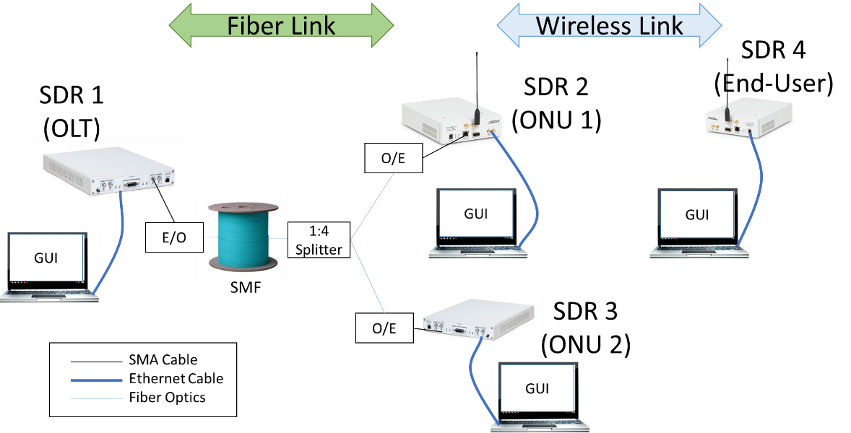
Fig.1. Hardware setup for the proposed FiWi testbed

Afterwards, the optical signals are reverted back to RF signals via the O/E. The data received by both SDR 2 and SDR 3 will be down-converted, sampled and streamed to the designated computer via 1 Gb Ethernet cable. SDR 2 will further transmit the signal wirelessly to SDR 4 without any converters needed as USRP works directly for wireless link.
In this project, USRP is integrated with LabVIEW as data source, signal processing and modulation of the testbed. LabVIEW is preferred for the FiWi testbed due to abundance of NI-USRP libraries and add-ons. The proposed testbed allows user to enter any data and the program will automatically convert the data into packets. For a more user-friendly purpose, the data to be transmitted are translated to number of packets where it allows user to directly choose range of packets to be transmitted.
The GUI for all OLT, ONU and End-User are as shown in Figure 2. The red constellation graph represents the output I/Q signals of the USRP. Whereas the white waveform graph indicates the data received by the SDR. With only one button pressed at the OLT’s user interface, the FiWi downstream transmission is performed automatically. User does not require to modify anything at the ONU’s and End-User’s interfaces except for the internet protocol (IP) addresses.
The receive and transmit parameters and modulations type can also be easily changed from the GUI. As can be seen in Figure 3, the sampling rate, gain and frequency can be adjusted according to preference. This make the testbed to be an easy-to-use platform without the requirement of tedious hardware re-configurations. It is worth mentioning that the types of modulation for the USRP are included together with the USRP modulation toolkit provided by NI.
Figure 4 (a) shows the flowchart for the transmission program. For transmission, user is required to input the data size, modulation type, packets parameters and transmit parameters. When the program starts, the data will calculate the total number of packets, N. The program will then generate the first packet, i. The program will shift the packet i to the USRP to transmit. Immediately, the program will generate the next packets until i is equivalent to N. Finally, the program will stop.
On the other hand, Fig. 4 (b) shows the flowchart for receive program. For receive program, the user will need to input the demodulation type, expected packets parameter and the receive parameter. Once the USRP captures the i packet from the transmitter, the program will retrieve accumulate all the packets captured by the receiver. Once the USRP stops receiving any packets, the program will stop.
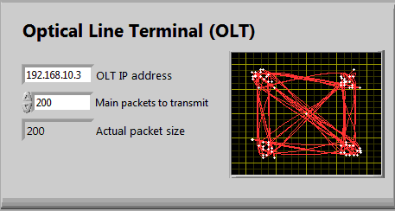
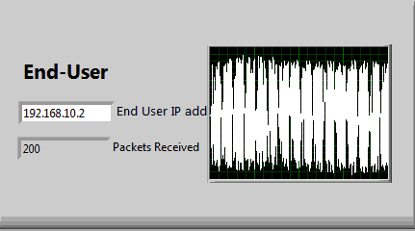
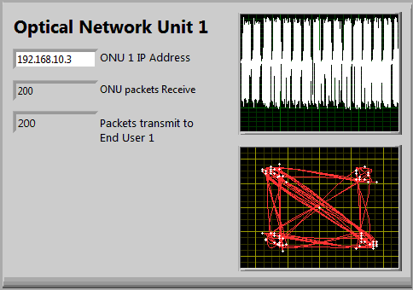

Fig. 2. User interface for OLT, ONU, and end-user

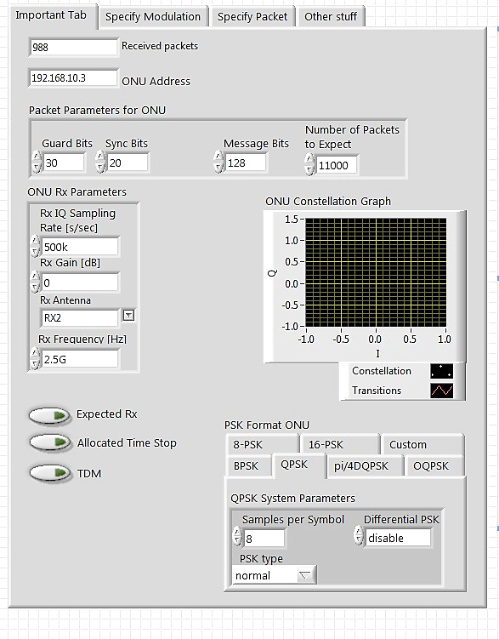
Fig. 3. User interface for receive parameters

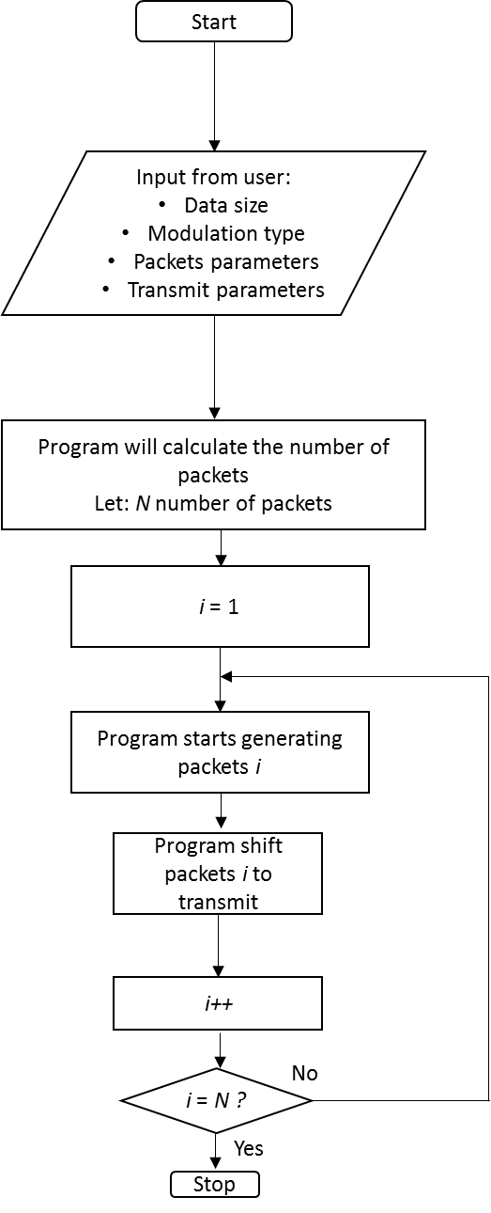  (a) | 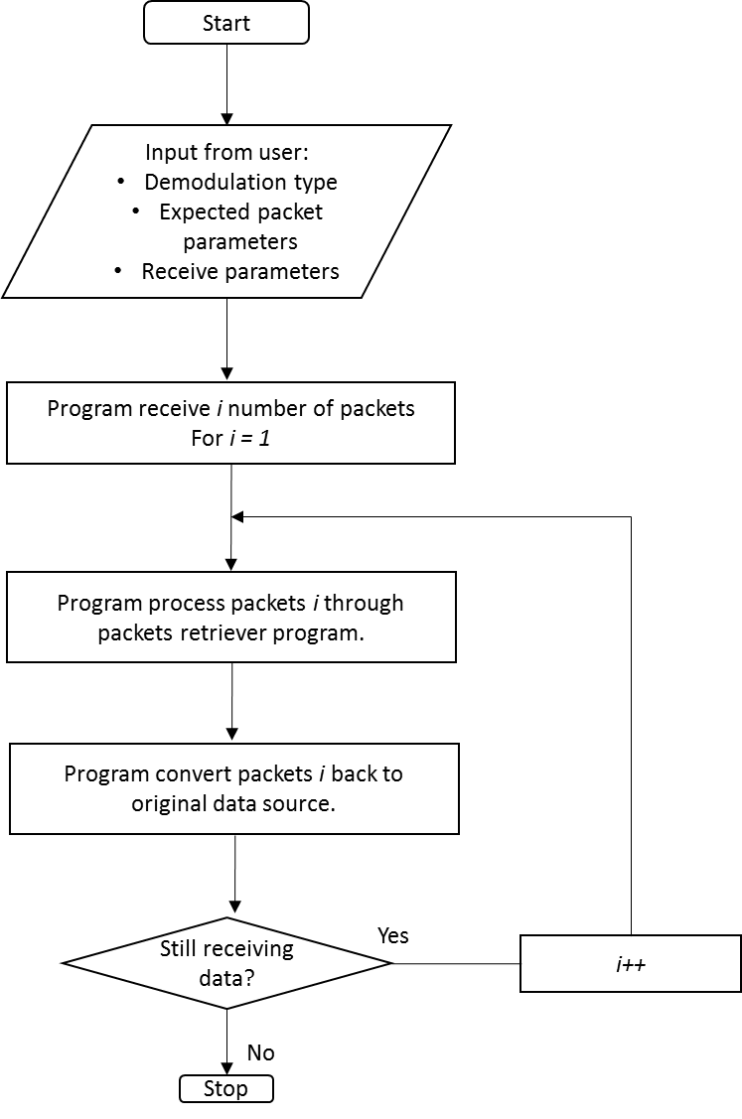  (b)
Fig. 4. Flowchart for (a) transmit and (b) receive program

The cycle time and guard time used in this experiment are 2 ms and 5 μs respectively as has been recommended by IEEE 802.3 [15] and ITU-T G.114 [16]. Instantaneous bandwidth is rated 40 MHz which means the USRP 2922 can continuously acquire 40 MHz of RF spectrum without retuning the local oscillator [17].
The transmission uses standard polling for upstream transmission where the end-user will first request the total bandwidth from the ONU. Then, the ONU will grant a time slot for the upstream transmission. The process is repeated for the transmission between ONU and OLT as shown in Figure 5. While for downstream transmission, OLT will broadcast the data to all ONUs and at the ONU’s side, if the address is matched, ONU will receive the data at an allocated timeslot. In this paper, it is assumed that all ONUs will receive the same data as it is just a proof-of-concept. The downstream transmission is as shown in Figure 6.
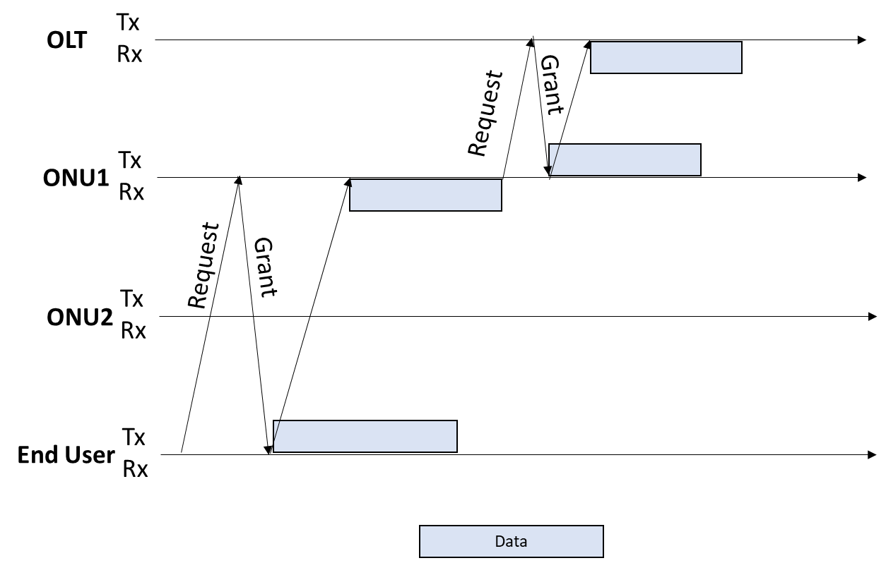
Figure 5 Upstream transmission

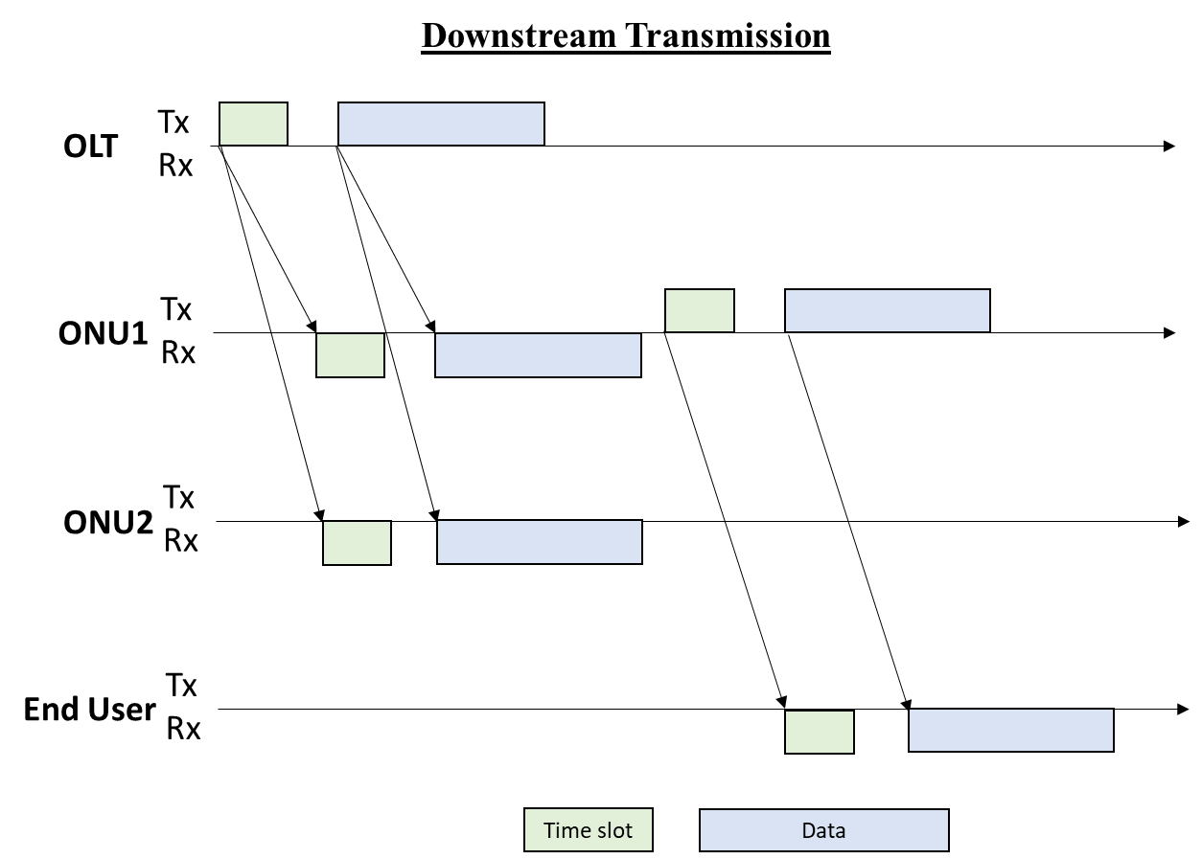
Figure 6 Downstream transmission

- Performance Evaluation of the Testbed

This section discusses on the performance evaluation of the proposed FiWi testbed and will be divided into three parts. The first part is preliminary study on investigating the suitable output power needed for the desired wireless range between USRPs. The second part is on the performance evaluation of the testbed in terms of throughput, transmission time and jitter. The final part is on testing the reconfigurability of the FiWi testbed.

3.1 Preliminary study

Since NI does not explicitly state the maximum wireless range of USRP (due to its dependency to the interference in the surrounding) as well as the output power needed for desired range, such study is essential to be done before evaluating the performance of the testbed. For the wireless range test, two USRPs are used to represent transmitter and receiver respectively. The distance between USRPs are first set to 10 m away from each other with 10 m increment for each iteration until the USRP that represents receiver no longer receives the data transmitted by the transmitter. The experiment took place indoor where there is no active wireless network activity took place such as WiFi network that shares approximately the same transmission frequency of the USRP which is between 2.4 to 2.5 GHz. The wireless range test is repeated using packets ranging from 1000 to 11000 packets and the average packets is recorded. A successful transmission is defined when the packets transmitted by the transmitter is received by the receiver without any packets loss.
The relationship between wireless distance and USRP output power is summarized in Table 3. It is found that the greater the distance, the greater the output power required by the USRP to transmit data. From the experiment, the maximum wireless distance is found to be 100 m with the USRP’s output set to 30 dB. It shows that for wireless range less than 20 m, the required output power is 10 dB. While for distance between 20 and 50 m, the power required is 15 dB and finally for distance between 50 and 100 m, the power output required is at its maximum which is 30 dB. The wireless range test shows that the maximum wireless range is at 100 m with the transmitter output power gain is at the maximum which is at 30 dB. After 100 m, the receiver no longer receives any signals from the transmitter. This concluded that the maximum wireless range for the USRP is at 100 m indoor. To further extend the wireless range, a higher power gain antenna may be connected at transmitter. Nonetheless, 100 m range is deemed suitable as it is the typical range used in WiFi network.
To further study the relationship between power output, distance and packets received, an experimental setup for wireless range is shown in Figure 7. The transmitter is placed at displacement 0 m and three receivers are placed at a displacement of 10, 50 and 100 m respectively. The wireless coverage between a transmitter and receiver are studied by varying the distance and the USRP’s power output.

Table 3. USRP output power for various wireless range
Output power (dB) | Wireless Range (m)
10 | <20 m
15 | 20 m – 50 m
30 | 50 m – 100 m

The result is shown in Figure 8. The graph in Figure 8 further validates the results in Table 3 where the greater the distance, the greater the output power required by the USRP. The green area under the graph shows the coverage area of the USRP wireless link at various output power from 0 to 30 dB. It can be concluded that the best output power to be used for wireless range of 100 m is 30dB. 100 m wireless range is chosen as it is typically used in WiFi network, following IEEE Standard 802.11a.

Fig. 7. Experimental setup for wireless range test

Fig. 8. Wireless range versus output power

3.2 Performance evaluation

After we have discovered the most suitable output power to cater 100 m distance between USRPs, we further study the throughput, transmission time and jitter of the FiWi testbed in upstream transmission. Upstream transmission is the transmission from End-User to the OLT. In this case, the End-User acts as a transmitter, OLT acts as a receiver while the ONUs work both ways.
Throughput is defined as the amount of packets received in a given period of time. In this study, offered load is varied from 0 to 1 Gbps with 0.1 Gbps step as in Fig. 9. As can be seen from the figure, OLT received all the packets that have been sent by the End-User. As the offered load is 1 Gbps, the throughput obtained is also 1 Gbps, proving that the testbed works well without any packet loss for ideal condition in the FiWi testbed.

Fig. 9. Throughput versus offered load for upstream transmission of FiWi testbed

Transmission time is defined as the total time required for a complete transmission from End-User to the OLT and it can be depicted in Fig. 10. As the offered load increases, the transmission time increases where at 0.75 Gbps load, the transmission time increases as high as 5.75 ms.
The jitter, J is calculated by using Equation 1 [18], in which packet delay variation, PDV refers to the packets transmission time variation which is achieved by using Equation 2 [18]. D_{i} is the delay of a transmission i, in transmitter j and N_{p} is the total number of receiving packets. D_{ave} is the average delay of transmission i in transmitter j that is achieved by using Equation 3 [18]. Jitter relates closely with transmission time where greater transmission time causes greater delay variations hence greater jitter. The results can be seen in Fig. 11 where when the offered load is 0.1 Gbps, the jitter is 52.5 µs. As the offered load increases, the jitter increases further, proving the concept of actual FiWi network.

$$Jitter \left(J\right)= \sqrt{PDV}$$ | (Equation 1)
$$PDV= \frac{\sum_{c=1}^{Np}{{( D_{i,j}-D_{ave})}^{2}}}{Np}$$ | (Equation 2)
$$D_{ave}= \frac{\sum_{c=1}^{Np}{D_{i,j}}}{N_{p}}$$ | (Equation 3)

This section proves that USRP-2922 is deemed suitable to be used as FiWi testbed. The following subsection will review the reconfigurability feature of the testbed.

Fig. 10. Transmission time versus offered load for upstream transmission of FiWi testbed

Fig. 11. Jitter versus offered load for upstream transmission of FiWi testbed

3.3 Testbed Reconfigurability

To prove the reconfigurability of the testbed, other topologies and other type of transmission are implemented in the testbed with just minor modification. Fi-Wi-Fi topology is useful when the optical network is not able to be deployed from one point to another due to geographical constraints such as rural area or river. For that reason, a wireless link is used to overcome the constraint. Fi-Wi-Fi testbed has been first developed by Lim et al. [19] and we have implemented it in our proposed USRP’s testbed as in Fig. 12. In Fig. 12, USRP 1 is connected to USRP 2 using fiber link while USRP 2 is further connected to USRP 3 via a wireless link. USRP 3 is connected to USRP 4 via fiber link again.

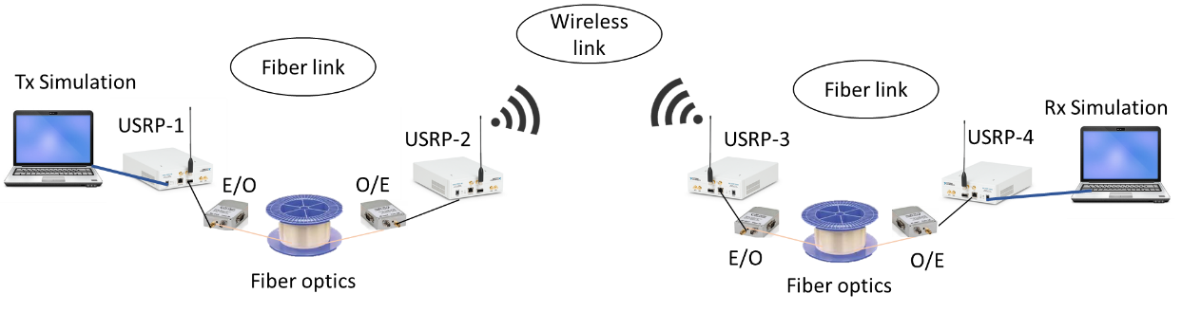
Fig. 12. Fi-Wi-Fi topology using USRP

The Fi-Wi-Fi topology is evaluated using USRP to obtain the performance such as number of packets received, transmission time and jitter. Since we have tested the FiWi network performance in upstream transmission previously, we tested the performance of Fi-Wi-Fi network in downstream transmission in this subsection. Hence, the data is recorded from the beginning of the USRP 1 transmission until the moment USRP 4 received all the data. It is noticeable that there is no packets loss for the transmission in the Fi-Wi-Fi as in Fig. 13, where as the number of packets transmitted by USRP 1 is 11000 packets, USRP 4 also receives 11000 packets. This indicates that the testbed works fine for other topology and other type of transmission.
The result of transmission time is as shown in Fig. 14. Due to the extended architecture, the time taken to complete the transmission from USRP 1 to USRP 4 has also increased significantly as expected. The increment in the number of packets received causes the transmission time to increase steadily. As it gets to 11000 packets, the transmission time increases as high as 238.5 s.

Fig. 13. Number of packets received versus number of packets transmitted for the Fi-Wi-Fi topology

Fig. 14. Transmission time versus number of packets received for Fi-Wi-Fi topology

The high transmission time further leads to the higher jitter as shown in Fig. 15. As the number of packets received increases, jitter also increases until it gets as high as 4s when the number of packets received is 11000 packets. Although it takes longer time to receive, it proves that the testbed is working successfully for different topology and different type of transmission, proving that the testbed is easily reconfigurable.

Fig. 15. Jitter versus number of packets received for the Fi-Wi-Fi topology

4. Conclusion
The feasibility of using NI-USRP which is the main radio for the proposed FiWi testbed has been presented in this paper. Despite of USRP’s main feature to transmit data in wireless link, it is also able to transmit data through fiber link by using RoF technology. By simply channeling the RF signals through E/O or O/E, the RF signals are able to be modulated into optical signals. In this paper, we have first studied the suitable output power and maximum wireless distance to be used between USRPs. We have identified that the maximum wireless distance between USRPs is 100 m, similar to typical WiFi netwok with the maximum output power of 30dB. We have also studied the performance of the proposed FiWi network in terms of throughput, transmission time and jitter for upstream transmission. The results confirm the FiWi concept which makes us further evaluate its reconfigurability feature. By changing the topology to Fi-Wi-Fi testbed and changing the type of transmission to downstream transmission, we have managed to prove that the testbed is able to be reconfigured for further FiWi studies.

References

[1] R. Lin, M. Zhu, Z. Zhou, H. Chen, J. Ye, “New progress of mm-wave radio-over-fiber system based on OFM,” Frontiers of Optoelectronics in China, 2(4):368-78, 2009.
[2] Y. Liu, J. Wu, Y. Yu, Z. Ning, X. Wang and K. Zhao, "Deployment of survivable fiber-wireless access for converged optical and data center networks", Optical Switching and Networking, vol. 14, pp. 226-232, 2014.
[3] Jalil YE, Kasi B, Chakrabarty CK. “A compact ultra wideband antenna with WiMax band rejection for energy scavenging”, IOP Conference Series: Earth and Environmental Science 2013 (Vol. 16, No. 1, p. 012100). IOP Publishing.
[4] U. Bhatt, T. Sarsodia and R. Upadhyay, "Performance Evaluation of Survivable Fiber-Wireless (FiWi) Access Network", Procedia Computer Science, vol. 46, pp. 1049-1055, 2015.
[5] J. Sun, L. Yu and Y. Zhong, "A single sideband radio-over-fiber system with improved dynamic range incorporating a dual-electrode dual-parallel Mach–Zehnder modulator", Optics Communications, vol. 336, pp. 315-318, 2015.
[6] Q. Dai, G. Shou, Y. Hu and Z. Guo, "Performance improvement for applying network virtualization in fiber-wireless (FiWi) access networks", Journal of Zhejiang University Science C, vol. 15, no. 11, pp. 1058-1070, 2014.
[7] K. Kang, Z. Zhu, D. Liu, W. Zhang and H. Qian, "A software defined open Wi-Fi platform", China Communications, vol. 14, no. 7, pp. 1-15, 2017.
[8] H. Hizan, T. Kanesan, S. Sadon, A. Ibrahim, M. Ismail, S. Hassan, R. Sanusi, A. Yusof, F. Maskuriy and S. Mitani, "Multiservice wireless network testbed design using SDR and RoF platforms", 2016 IEEE Asia-Pacific Conference on Applied Electromagnetics (APACE), 2016.
[9] A. McBride, B. Derveni, J. Proko, P. Kamsula, H. Chowdhury, T. Hanninen, J. Mäkelä and M. Katz, "Transitioning to Hybrid Radio/Optical Networks: Development of a Flexible Visible Light Communication Testbed", Proceedings of the 1st International Conference on 5G for Ubiquitous Connectivity, 2014.
[10] L. Chen, J. Yu, J. Xiao, X. Li, Y. Xu and Z. Zhang, "Fiber–wireless–fiber link for 20-Gb/s QPSK signal delivery at W-band with DML for E/O conversion in wireless–fiber connection", Optics Communications, vol. 354, pp. 231-235, 2015.
[11] R. Shaddad, A. Mohammad, A. Al-Hetar, S. Al-Gailani and M. Elmagzoub, "Fiber-wireless (FiWi) access network: Performance evaluation and scalability analysis of the physical layer", Optik - International Journal for Light and Electron Optics, vol. 125, no. 18, pp. 5334-5338, 2014.
[12] R. Zhang, J. Ma, Z. Wang, J. Zhang, Y. Li, G. Zheng, W. Liu, J. Yu, Q. Zhang, Q. Wang and R. Liu, "Full-duplex fiber-wireless link with 40Gbit/s 16-QAM signals for alternative wired and wireless accesses based on homodyne/heterodyne coherent detection", Optical Fiber Technology, vol. 20, no. 3, pp. 261-267, 2014.
[13] "Compare and buy USRP- National Instruments",Ni.com. [Online]. Available: http://www.ni.com/sdr/usrp/compare/
[14] National Instrument, "NI USRP 292x/293x Datasheet", 2015-08-17.
[15] IEEE 802.3ah task force home page, “IEEE P802.3ah Ethernet in the first mile task force.” [Online]. Available: http://www.ieee802.org/3/efm, 2004.
[16] ITU-T task force home page, “ITU-T Recommendation G.114 one-way transmission time, Transmission Systems and Media, Digital Systems and Networks.” [Online]. Available: http://www.itu.int/rec/T-REC-G, 2000.
[17] EE-times, “Understanding RF Instrument Specifications Part 1”, Matt Anderson and David Hall, National Instruments, 7/25/2007 06:00 AM EDT. [Online]. Available: http://www.eetimes.com/document.asp?doc_id=1276291
[18] X. Li, L. Dan, and Q. Wu, “Adaptive dynamic bandwidth allocation algorithm supporting multi-services over Ethernet passive optical networks,” Optik-International Journal for Light and Electron Optics, 2012.
[19] C. Lim, A. Nirmalathas, Y. Yang, “Digitized Wireless Transport for Fiber-Wireless System”, IEEE Transparent Optical Network , pp 1-4, June 2011

