Reply for comments from Reviewer P

- Text needs English prove.
Our reply:
Thank you very much for the comment, we have proof read the English manuscript as per requested.

- Define the abbreviations once in the paper.
Our reply:
Abbreviations have been defined at first usage as in the paper.

- Put Fig. 4 before section 3.
Our reply:
We have placed Fig. 4 before Section 3.

Reply for comments from Reviewer Q

- Experimental set up is very short. Author may increase the size up to 500 m.
Our reply:
Thank you for the suggestion.
In the experiments we did increase our range to more than 100 m. However, after 100 m, the receiver no longer receives any signals from the transmitter. Moreover, actual FiWi when fiber optics combined with WiFi also work in a range of 100 m following IEEE 802.11a standard. However, since we did not specify on the outcome beyond 100 m, we have included our explanations in Page 9, paragraph 2 as below:

After 100 m, the receiver no longer receives any signals from the transmitter. This concluded that the maximum wireless range for the USRP is at 100 m indoor. To further extend the wireless range, a higher power gain antenna may be connected at transmitter. Nonetheless, 100 m range is deemed suitable as it is the typical range used in WiFi network.

- Introduction section is poorly delivered. Since, in literature survey, the author overlooked many recent related works.
Our reply:
Thank you for the suggestions, we have included three more recent papers in our literature review.
They can be found in Page 2, pargraph 5 as below:

On the wireless side, Kal et al. [7] has developed an open WiFi platform designed with special consideration of real-time signal by using software defined radio (SDR) at the front end. With the benefits of SDR, their proposed platform supports fast prototyping and verification of new physical layer algorithms as well as the 5G with WiFi network architecture and upper layer evolutions.
Hizan et al. [8] presents a testbed design using SDR platforms for the next generation wireless access network that supports concurrent multiservice transmissions in which a heterogenous network is emulated. Their testbed results show that the measured error vector magnitudes are suitable for WiFi and LTE Access Points to operate effectively as receivers.
Kamsula et al. [9] reviews the major challenges and important applications of hybrid visible light communication (VLC)/RF networks using a SDR-based testbed. Given the low cost, minimal hardware requirements and experimentally flexible feature of SDR, the proposed testbed represents an ideal system to begin various VLC/RF related experiments in the future.

- Why author preferred the LabVIEW for their simulation? Why not other tools like MATLAB?

Our reply:
Although designing and prototyping the SDR systems using USRP is possible with MATLAB and Simulink. However, LabVIEW is preferred for the FiWi testbed due to abundance of NI-USRP libraries and add-ons available for LabVIEW. Besides, the libraries contain a higher-level open source functions codes such as modulation, demodulation, data packetizing and others will speed up the development of advanced applications. Programming the testbed is more feasible using LabVIEW over MATLAB due to its graphical programming environment and not to mentioned that GUI provided in LabVIEW eases the simulation process. Although incorporating complex mathematical formulae are easier to be implemented in MATLAB, LabVIEW also provides an add-on which is the MathScriptfunction module so that MATLAB functions can be integrated into LabVIEW easily.

We have added the justification in Page 5, Paragraph 2 as below:

In this project, USRP is integrated with LabVIEW as data source, signal processing and modulation of the testbed. LabVIEW is preferred for the FiWi testbed due to abundance of NI-USRP libraries and add-ons. The proposed testbed allows user to enter any data and the program will automatically convert the data into packets. For a more user-friendly purpose, the data to be transmitted are translated to number of packets where it allows user to directly choose range of packets to be transmitted.

- There is no comparative study with existing scheme.
Our reply:
The comparative study with existing scheme has been presented in this paper:

N. A. M. Radzi, M. A. Ridwan, F. Abdullah, N. M. Din, M. H. Al-Mansoori, “Effects of varying fiber length towards packet delay in Passive Optical Network”, IEEE Region 10 International Conference (TENCON), 2016

- Author evaluated the performance using only three factors such as throughput, transmission time and jitter. Why not more factors?

Our reply:
These three factors are the most important and relevant factors in studying the performance of FiWi network. Besides, these three parameters are the parameters being studied in most papers.

- What is packet transmission techniques used in proposed systems?

Our reply:
Thank you for the suggestion, we have included the packet transmission technique in the paper.

It can be found in Page 7, the last paragraph s below:

The transmission uses standard polling for upstream transmission where the end-user will first request the total bandwidth from the ONU. Then, the ONU will grant a time slot for the upstream transmission. The process is repeated for the transmission between ONU and OLT as shown in Figure 5. While for downstream transmission, OLT will broadcast the data to all ONUs and at the ONU’s side, if the address is matched, ONU will receive the data at an allocated timeslot. In this paper, it is assumed that all ONUs will receive the same data as it is just a proof-of-concept. The downstream transmission is as shown in Figure 6.
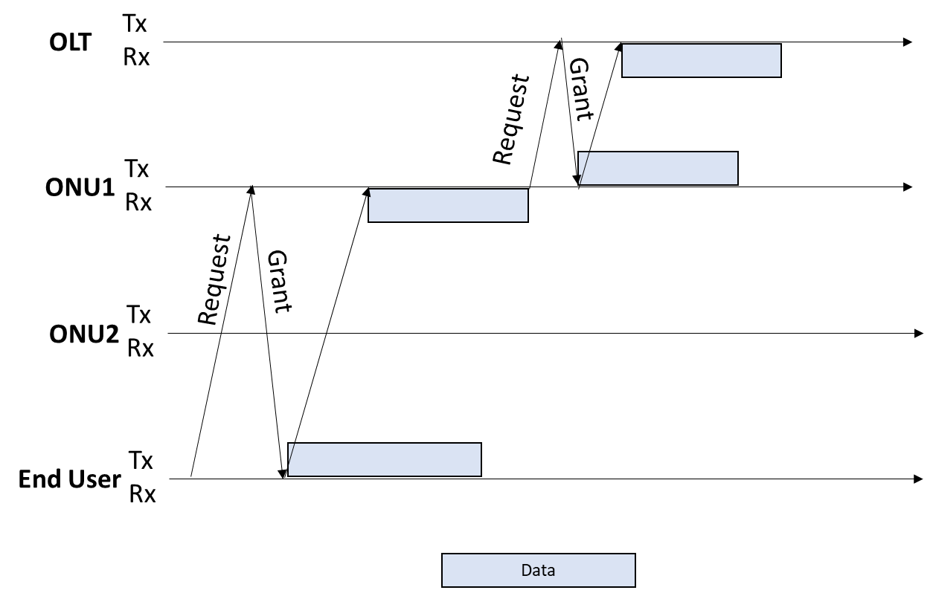
Figure 5 Upstream transmission

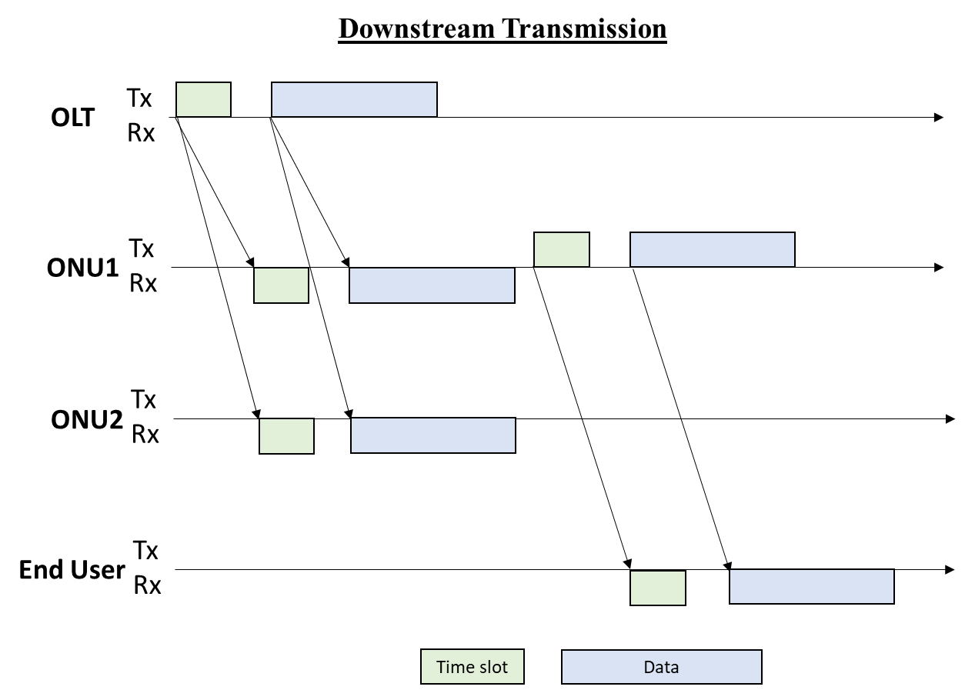
Figure 6 Downstream transmission

- What are transmission issues considered like packet loss. etc?

Our reply:
For the evaluation performance, a successful transmission is defined when the receiver received all the data from the transmitter. By varying the wireless range, fiber length and topology, the results show that the receiver received all data from the transmitter without any packets loss. The results proved that the USRP is suitable to be used as the main radio for the testbed is feasible for wireless link, fiber link and any topology. However, in the future, when an algorithm is implemented in the testbed such as dynamic bandwidth allocation, there will be a packets loss due to the bandwidth management incorporated in the testbed. Another issue should be considered is the wireless range.

