Oxidation of Titanium and Ti/(TiB+TiC) Composite

Poonam Yadav and Dong Bok Lee*
School of Advanced Materials Science and Engineering, Sungkyunkwan University, Suwon 16419, South Korea

Abstract

Titanium and titanium matrix composite reinforced with 10 vol.% (TiB+TiC) were oxidized at 700, 800 and 900 ºC for 30, 50 and 70 h, and their oxidation behavior was studied. The oxide scales consisted of rutile-TiO₂ without any other oxides, and thickened with an increase in the oxidation time and temperature. Large growth and thermal stress generated during oxidation, voids formed around the scale/matrix interface, and the oxide scales were susceptible to cracking.
Keywords: Titanium, Titanium matrix composite, Oxidation, Oxide scale

- Introduction
Titanium and titanium alloys are light in weight, have high tensile strength, toughness, and excellent corrosion resistance. They are widely used for highly demanding structural parts such as aircrafts, chemical plants, automobiles, ocean engineering, oil refinery, medical devices, highly stressed components, and military applications [1-3]. Recently, the introduction of particulates or continuous fibers with low density and high modulus into titanium alloys has further improved the specific modulus, specific strength, creep resistance, wear resistance, and the
*Corresponding author,
Email: dlee@skku.ac.kr,
[Tel: +82-31-290-7355]
service temperatures [4–8]. In order to utilize the titanium matrix composites (TMC) for industrial purpose, the oxidation study is imperative. In this study, the oxidation behavior of titanium and titanium matrix composite reinforced with 10 vol.% (TiB+TiC) particulates (hereafter, designated as 10TMC) were investigated after isothermally oxidizing at 700-900 ºC for 30-70 h in air. Particulate-reinforced titanium matrix composites have attracted considerable attentions.

- Experimental
Titanium and 10TMC were prepared. They were cut to 10x10x2 mm³ in size, metallographically polished, and cleaned ultrasonically in ethanol, and oxidized at 700, 800 and 900 ºC for 30, 50 and 70 h in air. Following oxidation, matrix phases and formed oxide scales were investigated using scanning electron microscopy (SEM) equipped with energy dispersive spectroscopy (EDS), X-ray diffraction (XRD) using Cu-Kα radiation operated at 40 kV and 100 mA. The matrix grain sizes were measured through the conventional mean-linear-intercept method using SEM. The Vickers microhardness was measured with a load of 100 N for 5 sec for more than 5 points on each sample at room temperature.

- Results and discussion
Fig. 1 shows the X-ray diffraction patterns of the oxide scales formed after isothermal oxidation at 800 ºC for 70 h. For titanium and 10TMC, the oxide scales consisted of rutile-TiO₂ without any other oxides. Apparently, boron and carbon in (TiB+TiC) evaporated during oxidation.
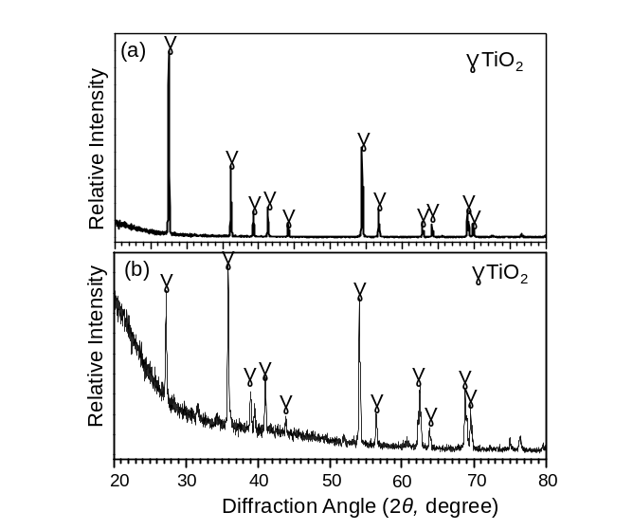
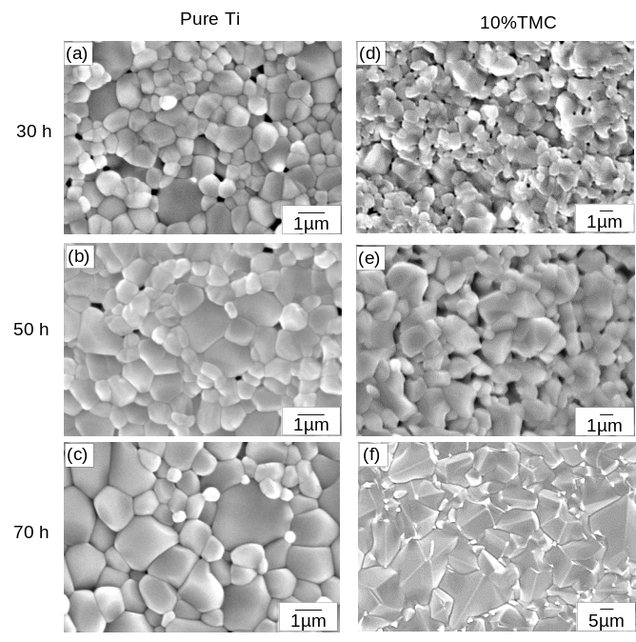

Fig. 1 X-ray diffraction patterns after oxidation at 800 ºC for 70 h. (a) Titanium, (b) Titanium matrix composite reinforced with 10 vol.% (TiB+TiC)
A series of representative SEM micrographs are shown in Fig. 2. The oxide grain size of 10TMC increased with an increase in oxidation time more rapidly than that of titanium. Particularly, the coarse rutile-TiO₂ grains that formed on 10TMC after oxidation at 900 °C for 70 h were noticeable.
Fig. 3 shows the grain evolution of oxide grains that formed on 10TMC as a function of the oxidation temperature. The grain size clearly increased in proportion to the oxidation temperature, owing to the increased reaction and diffusion rates at

high temperatures.

Fig. 4 shows the cross-section of titanium and 10TMC after oxidation at 900 ºC for 30, 50, and 70 h. As the oxidation reaction preceded, more growth stress generated to induce cracking and detachment of the oxide scale, and more voids formed around the scale/metal interface that could act as stress concentration sites.
Fig. 2 SEM top view after oxidation at 900 °C. Titanium for (a) 30 h, (b) 50 h, and (c) 70 h. Titanium matrix composite reinforced with 10 vol.% (TiB+TiC) for (d) 30 h, (e) 50 h, and (f) 70 h

Voids apparently formed owing to the significant outward diffusion of Ti ions to form thick TiO₂ oxide scale. The average thickness of the oxide scale was 340 μm (Fig. 4(a)), 350 μm (Fig. 4(b)), 400 μm (Fig. 4(c)), 125 μm (Fig. 4(d)), 170 μm (Fig. 4(e)), and 190 μm (Fig. 4(f)). The addition of 10 vol.% (TiB+TiC) beneficially improved the oxidation resistance of the Ti metal.

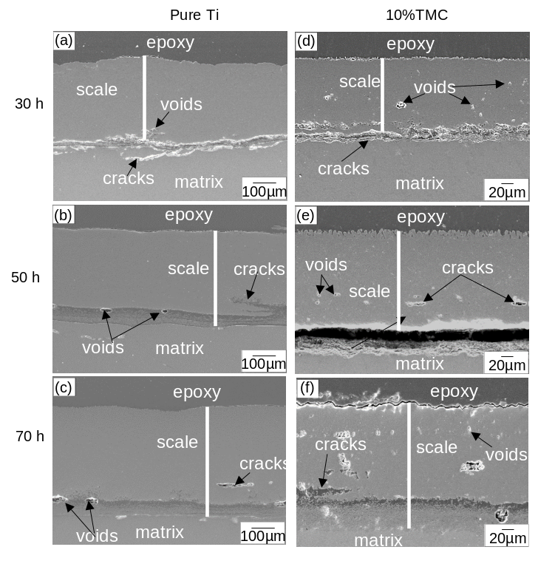
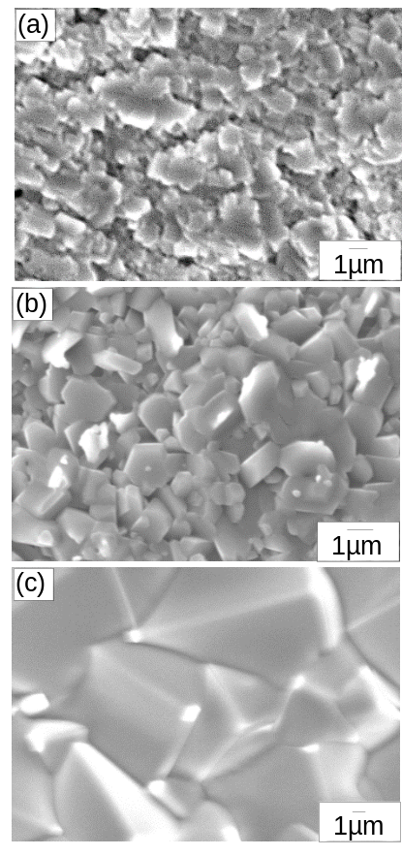

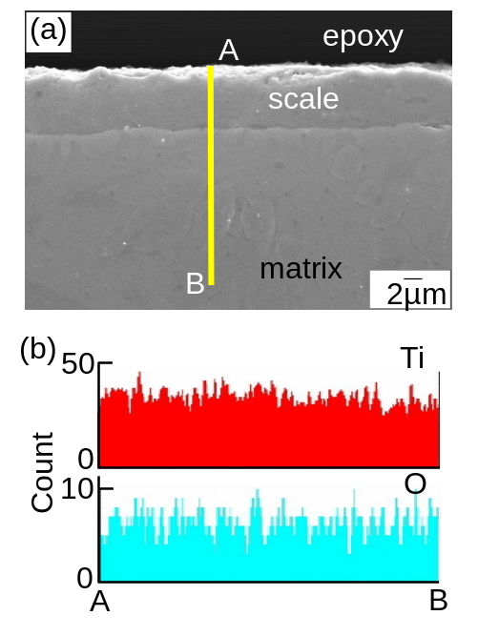
Fig. 3 SEM top view of oxide scales formed on Titanium matrix composite reinforced with 10 vol.% (TiB+TiC) after oxidation for 70 h at (a) 700 °C, (b) 800 °C, and (c) 900 °C

Figure 5 shows the SEM/EDS analytical result of 10TMC after oxidation at 700 °C for 70 h. The oxide scale was 7 μm-thick (Fig. 5(a)). Unlike Fig. 4, the oxide scale was dense, adherent, and crack-free owing to the small growth and thermal stress generated.

Vickers microhardness of 10TMC was measured at the surface of the formed oxides as a function of the oxidation time and temperature, and displayed in Fig. 6. During the early oxidation period, the microhardness increased at all temperatures owing to the formation of thin but hard oxide scales. The

Fig. 4 SEM cross-section after oxidation at 900 °C. Titanium for (a) 30 h, (b) 50 h, and (c) 70 h. Titanium matrix composite reinforced with 10 vol.% (TiB+TiC) for (d) 30 h, (e) 50 h, and (f) 70 h

Fig. 5 Titanium matrix composite reinforced with 10 vol.% (TiB+TiC) after oxidation at 700 °C for 70 h. SEM cross-section, (b) EDS line profiles along A-B

higher the temperature was, the higher the microhardness was.

At the later stage of oxidation, the microhardness decreased to a certain extent. The higher the temperature was, the microhardness decreased more. This may be attributed to stress relieving of the oxide grains arisen during heating.
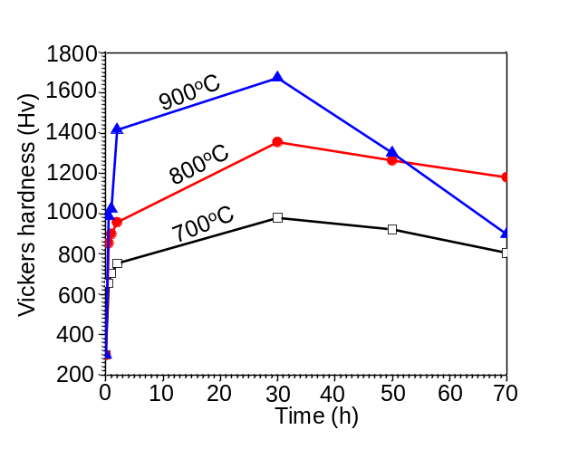

Fig.6 Microhardness of Titanium matrix composite reinforced with 10 vol.% (TiB+TiC) as a function of oxidation time and temperature, which was taken at the top oxide surface

- Conclusions
The oxidation behavior of titanium and 10TMC was investigated after isothermally oxidizing at 700, 800 and 900 ºC for up to 70 h. The XRD analysis revealed that the oxide scale consisted of rutile-TiO₂. The scale thickness, growth and thermal stress increased with the increase in the oxidation time and temperature. The oxidation at 900 ºC for 70 h led to the cracking and void formation in the oxide scale as well as around the oxide scale/matrix interface. Microhardness of the oxide scale increased at the early oxidation period, and decreased at the later period due to the stress-relieving arisen by the oxide grain growth.

Acknowledgments
This work was supported by the Human Resource Development Program (No. 20134030200360) of the Korea Institute of Energy Technology Evaluation and Planning (KETEP) grant funded by the Korea government Ministry of Trade, Industry and Energy.

- References
- M. Yamada, “An overview on the development of titanium alloys for non-aerospace application in Japan,” Material Science and Engineering, A vol. 213, pp. 8-15, 1996.
- M. Peters, J. Hemptenmacher, J. Kumpfert, and C. Leyens, Titanium and Titanium Alloys: fundamentals and applications Germany: WILEY-VCH, pp. 1-36, 2003.
- S. R. Seagle, “The state of the USA titanium industry in 1995,” Material Science and Engineering, A vol. 213, pp. 1-7, 1996.
- S. Abkowitz, P. F. Weihrauch, S. M. Abkowitz, and .H. L. Heussi, “The commercial application of low-cost titanium composites,” Journal of Metals, vol. 47, pp. 40-41, 1995.
- S. Ranganath, “A review on particulate-reinforced titanium matrix composites,” Journal of Materials Science, vol. 32, pp. 1-16, 1997.
- T. Saito, T. Furuta, and T. Yamaguchi, “Recent advances in titanium metal matrix composites,” USA, TMS, Warrendale, PA, 33-44. 1995
- T. Yamamoto, A. Otsuki, and K. Ishihara, “Synthesis of near net shape high density TiB/Ti composite,” Material Science Engineering, A vol. 239, pp. 239-240. 1997.
- D. B. Lee, Y. C. Lee, and D. J. Kim, “The Oxidation of TiB₂ ceramics containing Cr and Fe,” Oxidation of Metals, vol. 56, pp. 177-189, 2001.

