**List of figure**

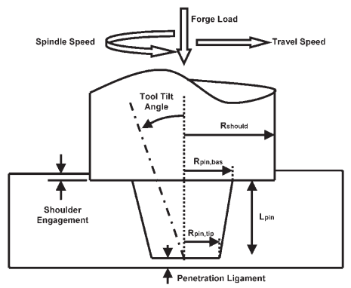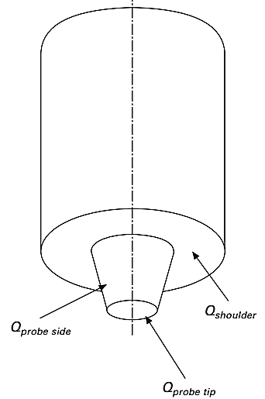

Fig. 1 Schematic tool geometry of heat generation contributions from the shoulder, probe side and probe tip.

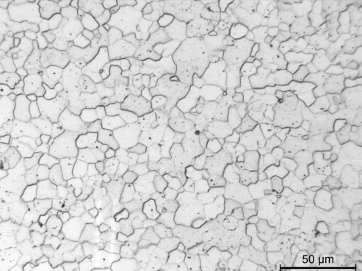

Fig. 2 Optical micrograph of IF steel sheet material

**List of tables**

Table 1 Chemical composition of the selected IF steel (in wt %)

|  |  |  |  |  |  |  |  |  |
| --- | --- | --- | --- | --- | --- | --- | --- | --- |
| C | Mn | S | Si | Al | N2 | Ti | P | Fe |
| 0.002 | 0.079 | 0.0089 | 0.006 | 0.0359 | 0.003 | 0.0657 | 0.0109 | Balance |

Table 2 Typical mechanical properties of IF steel at room temperature

|  |  |
| --- | --- |
| Material properties | IF Steel |
| Yield stress (N/mm²) | 137 |
| Density (kg/m3) | 7870 |
| Thermal conductivity (W/m ̊ C) | 51.9 |
| Specific heat (J/kg ̊ C) | 461 |
| Young’s modulus E (GPa) | 200 |
| Melting temperature (K) | 1800 |
| Frictional coefficient | 0.4 |
| Range of strain rates (per Second) | 0.001 to 750 |
| Tensile strength (N/mm²) | 302 |

Table 3 Heat generated during friction stir welding at Various Speed.

|  |  |  |  |  |  |  |  |
| --- | --- | --- | --- | --- | --- | --- | --- |
| Rotation Speed  (rpm) | Qshoulder-  rotation | Qshoulder-  translation | Qpin-rotation | Qpin-translation | Qpin tip-rotation | Qpin tip-translation | Total heat (watt) |
| 250 | 684.366 | 179.398 | 32.438 | 63.459 | 13.8649 | 15.187 | 988.7 |
| 300 | 821.228 | 179.398 | 38.925 | 63.459 | 16.637 | 15.187 | 1134.8 |
| 350 | 957.228 | 179.398 | 45.372 | 63.459 | 19.639 | 15.187 | 1280.04 |
| 400 | 1094.98 | 179.398 | 51.9 | 63.459 | 22.184 | 15.187 | 1427.108 |
| 450 | 1231.843 | 179.398 | 58.388 | 63.459 | 24.956 | 15.187 | 1573.23 |
| 500 | 1395.04 | 179.398 | 66.123 | 63.459 | 28.263 | 15.187 | 1747.47 |
| 550 | 1505.594 | 179.398 | 71.363 | 63.459 | 30.5 | 15.187 | 1865.5 |
| 600 | 1642.457 | 179.398 | 77.850 | 63.459 | 33.275 | 15.187 | 2011.63 |
| 650 | 1779.346 | 179.398 | 84.339 | 63.459 | 36.048 | 15.187 | 2157.77 |
| 700 | 1916.21 | 179.398 | 90.826 | 63.459 | 38.82 | 15.187 | 2303.899 |

Table 4 Total torque and Power generated Friction stir Welding in Various speed and different diameter (Tool shoulder and pin dia.) by using design of Experiment.

|  |  |  |  |  |  |  |
| --- | --- | --- | --- | --- | --- | --- |
| SL. No. | Rotational Speed (rpm) | Shoulder dia. (mm) | Pin dia. (mm) | Torque (kN-mm) | Power (kW) | Local heat flux (W/mm2) |
| 1 | 250 | 18 | 6.0 | 127.4 | 3.34 | 12.559 |
| 2 | 250 | 16 | 5.5 | 90.413 | 2.365 | 11.265 |
| 3 | 250 | 15 | 5.0 | 74.5 | 1.949 | 10.443 |
| 4 | 250 | 12 | 4.0 | 38.75 | 1.014 | 8.357 |
| 5 | 350 | 18 | 5.5 | 126.344 | 4.628 | 17.186 |
| 6 | 350 | 16 | 6.0 | 91.484 | 3.351 | 16.084 |
| 7 | 350 | 15 | 4.0 | 72.835 | 2.668 | 13.896 |
| 8 | 350 | 12 | 5.0 | 39.9 | 1.46 | 12.251 |
| 9 | 450 | 18 | 5.0 | 124.866 | 5.88 | 21.539 |
| 10 | 450 | 16 | 4.0 | 87.758 | 4.133 | 18.807 |
| 11 | 450 | 15 | 6.0 | 76.56 | 3.606 | 19.739 |
| 12 | 450 | 12 | 5.5 | 41.4 | 1.949 | 16.433 |
| 13 | 600 | 18 | 4.0 | 123.69 | 7.767 | 27.587 |
| 14 | 600 | 16 | 5.0 | 88.935 | 5.585 | 26.181 |
| 15 | 600 | 15 | 5.5 | 75.49 | 4.74 | 25.692 |
| 16 | 600 | 12 | 6.0 | 42.472 | 2.667 | 22.542 |

Table 5 Analysis of variance table for torque

|  |  |  |  |  |  |
| --- | --- | --- | --- | --- | --- |
| Analysis of variance for torque: (Response Surface Regression: R-sq = 98.32% R-sq(adj) = 97.90%, R-sq(pred) = 96.77%, S = 4.57174. | | | | | |
| Source | DF | Adj SS | Adj MS | F-Value | P-Value |
| Regression | 3 | 14653.0 | 4884.3 | 233.69 | 0.000 |
| Linear | 3 | 14653.0 | 4884.3 | 233.69 | 0.000 |
| Tool rotation speed | 1 | 0.0 | 0.0 | 0.0 | 0.975 |
| Shoulder dia. | 1 | 14622.4 | 14622.4 | 699.61 | 0.000 |
| Pin dia. | 1 | 30.6 | 30.6 | 1.46 | 0.250 |
| Residual Error | 12 | 250.8 | 20.9 |  |  |
| Total | 15 | 14903.8 |  |  |  |

Table 6 Analysis of variance table for power

|  |  |  |  |  |  |
| --- | --- | --- | --- | --- | --- |
| Analysis of variance for power: (Response Surface Regression: S = 0.367969, R-sq = 96.70%, R-sq(adj) = 95.88%, R-sq(pred) = 92.81%. | | | | | |
| Source | DF | Adj SS | Adj MS | F-Value | P-Value |
| Regression | 3 | 47.6152 | 15.8717 | 117.22 | 0.000 |
| Linear | 3 | 47.6152 | 15.8717 | 117.22 | 0.000 |
| Tool rotation speed | 1 | 19.9632 | 19.9632 | 147.44 | 0.000 |
| Shoulder dia. | 1 | 26.6811 | 26.6811 | 197.05 | 0.000 |
| Pin dia. | 1 | 0.9709 | 0.9709 | 7.17 | 0.020 |
| Residual Error | 12 | 1.6248 | 0.1354 |  |  |
| Total | 15 | 49.2401 |  |  |  |

Table 7 Analysis of variance table for local heat flux

|  |  |  |  |  |  |
| --- | --- | --- | --- | --- | --- |
| Analysis of variance for local heat flux: (Response Surface Regression: S = 0.439876, R-sq = 99.56%, R-sq(adj) = 99.46%, R-sq(pred) = 99.04%. | | | | | |
| Source | DF | Adj SS | Adj MS | F-Value | P-Value |
| Regression | 3 | 530.799 | 176.933 | 914.42 | 0.000 |
| Linear | 3 | 530.799 | 176.933 | 914.42 | 0.000 |
| Tool rotation speed | 1 | 481.990 | 481.990 | 2491.02 | 0.000 |
| Shoulder dia. | 1 | 48.097 | 48.097 | 248.58 | 0.000 |
| Pin dia. | 1 | 0.711 | 0.711 | 3.68 | 0.079 |
| Residual Error | 12 | 2.322 | 0.193 |  |  |
| Total | 15 | 533.121 |  |  |  |

**List of graphs**



Fig. 3 Variation of Heat input with Tool rotation speed



Fig. 4 Variation of heat generation with Tool rotation speed for tapered cylindrical pin



Fig. 5 Variation of heat generation with tool rotation speed for cylindrical pin profile



Fig. 6 Variation of torque, power and local heat flux against rotation speed, shoulder diameter and pin diameter.